Technical Story Card

Revision History
Version No. | Date | Prepared by / Modified by | Significant Changes

Glossary
Abbreviation | Description
BSC | Business Story Card
TSC | Technical Story Card

Table of Contents
1 Introduction 3
2 Scope of Change 3
3 List of impacted modules 3
4 Design and Detailed technical updates 4
4.1 Process model 4
4.1.1 Use case Model 4
4.1.2 Sequence diagram 4
4.2 Proposed user Interface design 4
4.3 Database design changes 4
5 Other Technical changes 5
5.1 Automation tasks / changes 5
5.2 Non-functional related changes 5
6 References 5

Introduction
The "Gym Management System" has been developed to override the problems prevailing in the practicing manual system. Moreover, this system is designed for the need of the gym to carry out operations in a smooth and effective manner.
The application is reduced as much as possible to avoid errors while entering the data. It also provides error message while entering invalid data. No formal knowledge is needed for the user to use this system. Thus, by this all it proves it is user-friendly. Gym Management System, as described above, can lead to error free, secure, reliable, and fast management system. It can assist the user to concentrate on their other activities rather to concentrate on the record keeping. Thus, it will help organization in better utilization of resources.
Every organization, whether big or small, has challenges to overcome and managing the information of Attendance, Gym, Package, payment, selling. Every Gym Management System has different Gym needs; therefore, we design exclusive employee management systems that are adapted to your managerial requirements. This is designed to assist in strategic planning and will help you ensure that your organization is equipped with the right level of information and details for your future goals. These systems will ultimately allow you to better manage resources.

Scope of Change
- It meets the needs of the users.
- Be easy to understand by the user
- Be simple to use.
- User Interfaces are user friendly to handle it.
- This application is used in various management system.
Ex:- Coaching centers.

List of impacted modules

Register Module
- Used to collect the new user details
- Handle member's registration

Login Module
- Used to login admin and trainers
- Used to managed the login details
- It will redirect the pages for admin and trainer

Inventory
- Mange’s the product details

Payment
- Manages the payment details of the members who are visiting in the GYM

Attendance
- Manages attendances of trainees

Admin
- Manages and updates the packages
- Manages the trainer details
- Deleing the invoices

Design and Detailed technical updates

Process model

Use case Model

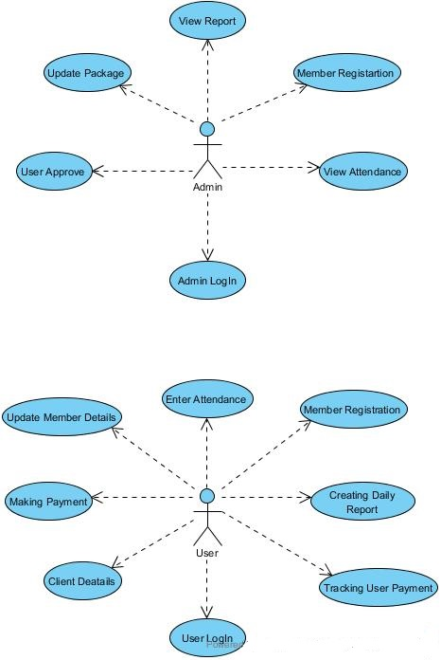
Selling Supplements
Selling Groceries

Block Members & unblock
Groceries

(Trainer))
Brief Description | Client’s Payment make
Basic Flow | This use case describes how a client’s payment made in the system  - Users must enter client’s membership id.  - If Membership id is valid then relevant fields shows client name, client package, next payment date, if any payments remaining to made and price of package. If client Member id is invalid that shows Invalid Id in relevant field.  - If client is newly joining there will be admission fee automatically add and if client absent for three months, it also adds admission fee again. If client failed to made payment on their next payment date and if it already passed 3 days, it also automatically adds late charges.  - The following information is required during payment made.  - Client’s Member Id
Alternate Flow | - The system will validate the information provided. If any invalid data is found, the input form will be redirected with error message or shows error messages in relevant field.
Validation | - Client’s member id is required, and it should be numeric.  - Account details should be valid.  - Account should be active
Pre-Conditions | User should have network access and Browser with latest updates.
Post-Conditions | Success message should be shown.

Gym Management System
Home POS Attendance Registration Daily Report Inventory Member Details
Invoice ID:XXXXX XXX9393INV9316
Membership Status: XXXXX XXX9393INV9316
Member Status : XXXXX XXX9393INV9316
Member ID

New Member

Package

Price

Discounts%

Status
Member ID

Member ID

Print
Search by Name
Name M ID
Total

Net Total
Payment
Balance
Due Amount

Workout Type Price Discount Total

Brief Description | Admin Panel – Packages Update
Basic Flow | This use case describes how a admin panel update the package in the system  - Admin can change the WorkOutType and Price  - The following details should be visible in the update package panel  - WorkOutTypeID  - WorkOutType  - Price
Alternate Flow | - The system will validate the information provided. If any invalid data is found, the input form will be redirected with error message or shows error messages in relevant field.
Validation | - WorkOutTypeID id is view in not editable format, and it should be numeric.  - WorkOutType is view in the proper format which can include in numeric and text as well  - Price should be in the numeric value and decimal places also should be view in the row
Pre-Conditions | User should have network access and Browser with latest updates.
Post-Conditions | Success message should be shown.

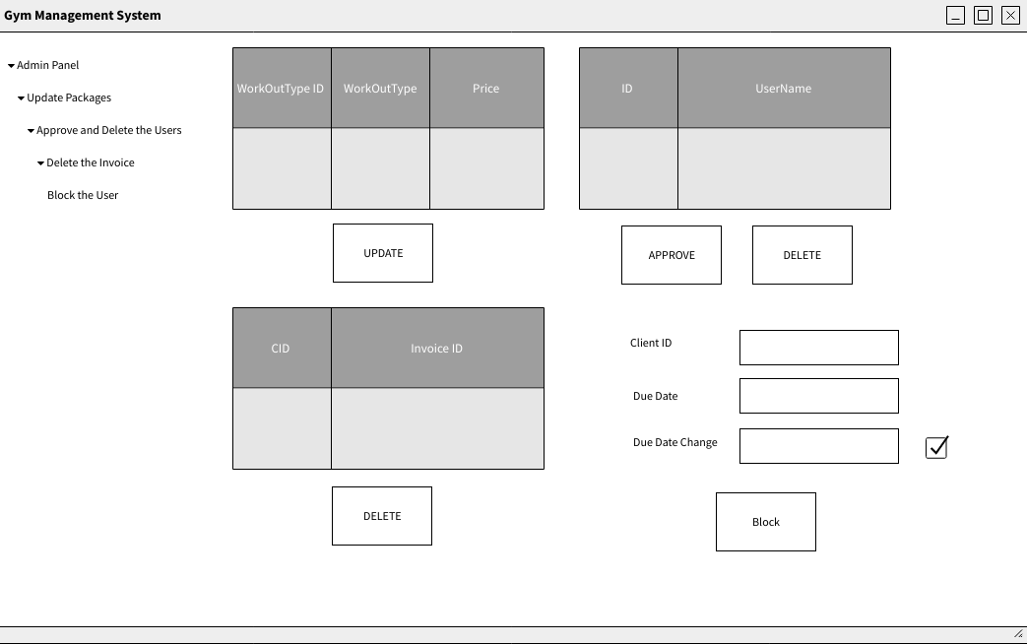
Brief Description | Admin Panel – Approve and Delete the Users
Basic Flow | This use case describes how a user’s update will take place in the admin panel.  - Admin should approve the request from the users for their logins  - The following details should be visible in the approve and delete the users in the panel  - ID  - Username  - Password
Alternate Flow | - The system will validate the information provided. If any invalid data is found, the input form will be redirected with error message or shows error messages in relevant field.
Validation | - password should be included at least 8 characters  - Username must be a user’s name  - UserID get an auto increment value
Pre-Conditions | User should have network access and Browser with latest updates.
Post-Conditions | Success message should be shown.

Brief Description | Admin Panel – Delete Invoice
Basic Flow | This use case describes how a admin can delete the invoice in the system  - Admin can delete the customer’s invoice  - The following details should be visible in the delete invoice panel  - CID  - Invoice ID
Alternate Flow | - The system will validate the information provided. If any invalid data is found, the input form will be redirected with error message or shows error messages in relevant field.
Validation | - Customer ID cannot be in the editable format  - InvoiceID should starts with the “INV<Number>”
Pre-Conditions | User should have network access and Browser with latest updates.
Post-Conditions | Success message should be shown.

Brief Description | Admin Panel – Block the user
Basic Flow | This use case describes how a admin can block the user and change the due date in the system  - Admin can block the user and change the due date  - The following details should visible in the block the user panel  - ClientID  - DueDate  - DueDate Change
Alternate Flow | - The system will validate the information provided. If any invalid data is found, the input form will be redirected with error message or shows error messages in relevant field.
Validation | - Admin should enter the customer ID in the field correctly  - Due Date field is not in the editable format.
Pre-Conditions | User should have network access and Browser with latest updates.
Post-Conditions | Success message should be shown.

Brief Description | User Registration
Basic Flow | This use case describes how a user register in to the system  - The user has to register into the system.  - After the successful registration, user will get a success message.  - The following information is required during registration.  - Name  - Address  - Email  - Mobile Number  - Gender  - NIC  - Package  - Medical Conditions
Alternate Flow | - The system will validate the information provided. If any invalid data is found, the input form will be redirected with error message.
Validation | - All Fields are required.  - Package should be selected from a drop-down.  - The Email should be valid.
Pre-Conditions | User should have network access and Browser with latest updates.
Post-Conditions | Success message should be shown.

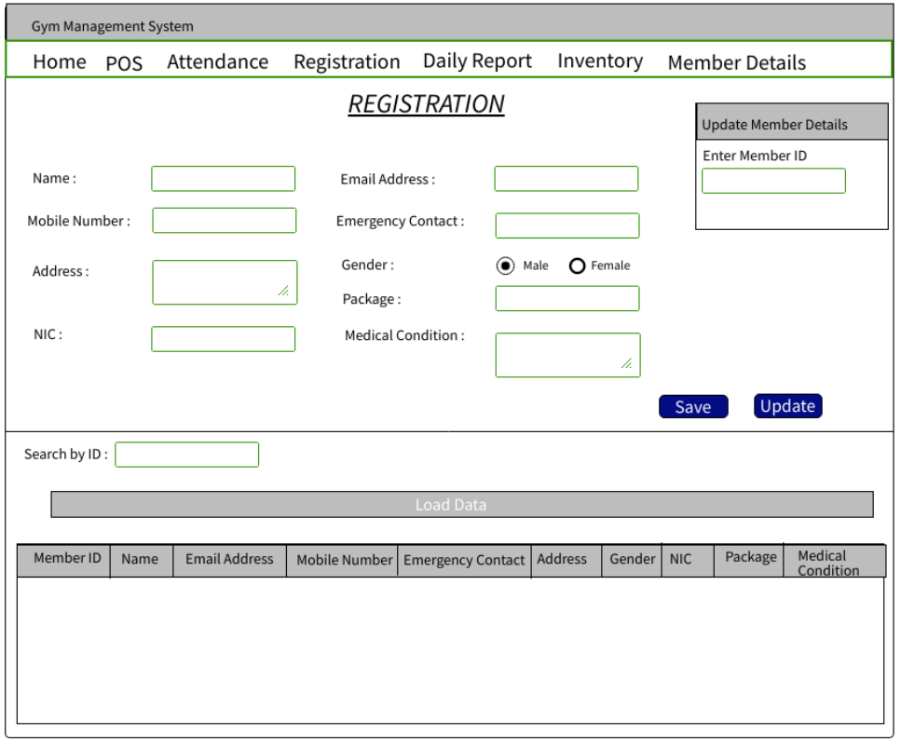
Brief Description | Adding product to stock
Basic Flow | This use case describes how admin or trainer add products to the system  - Category/inventory page shown to the system  - Admin select category to add product  - Select the quantity  - Added the product  - Successfully added message display  - Admin exit the system.
Alternate Flow | - Already existing product then update the qty. If there is a new product, then it will directly add to the system.
Validation | - System validates required quantity available in the system if not, user cannot get the product
Pre-Conditions | Admin should log to system
Post-Conditions | Product successfully added message shown

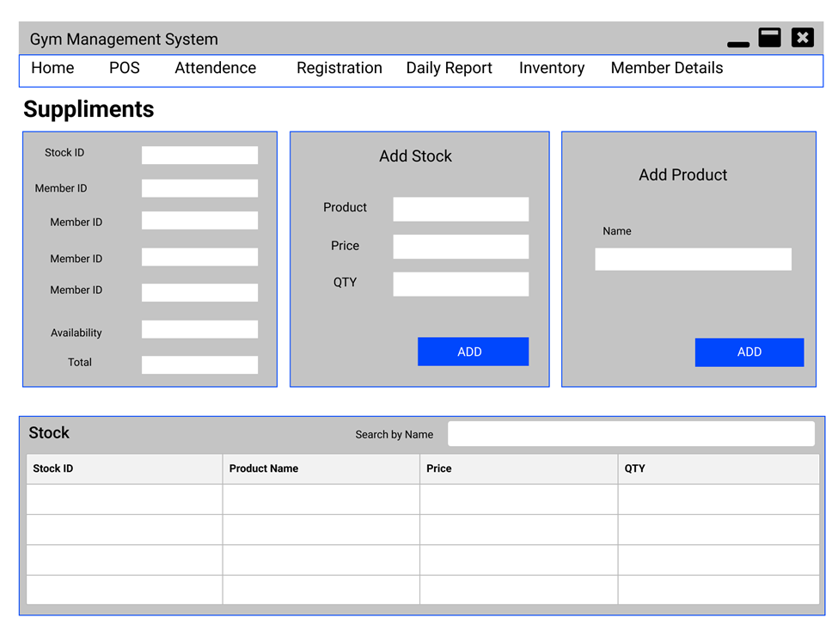

Brief Description | User buys product
Basic Flow | This use case describes how a User buys product from the trainer or the admin  - Trainer enters the user id.  - Trainer enters the product  - Select the quantity  - Calculate the amount that should display to the user  - Successfully message display to the user  - Trainer exits the system
Alternate Flow | 1. If the selected quantity greater than available system should display error message
Validation | - Select quantity validation to check the condition of validity in products quantity
Pre-Conditions | User should log to system
Post-Conditions | Total cost display with purchased message

Brief Description | Manage Attendance
Basic Flow | Staff member can mark the attendance with check-in and check-out time of each gym member  - Go to the ‘Attendance Insert’ page.  - Enter the Member ID of the gym member and enter the check-in time.  - Insert the daily workout type, which the gym member wants to follow on that day.  - System displays the Due amount which must pay by the gym member.  - At last check-out time of the Gym member will be marked.
Alternate Flow | - All input fields will be validated by the system. If there any error, an error message is displayed.  - There is a limitation for the number of days can be attend by a gym member in a month. If a gym member wants to use the gym exceeding the limit of the days, additional charges will be applied.
Validation | - Gym member id is required.  - Check-in and check-out time should be in right format.  - Workout type should be valid.
Pre-Conditions | Staff member should have login the system.
Post-Conditions | Generate a daily attendance report.

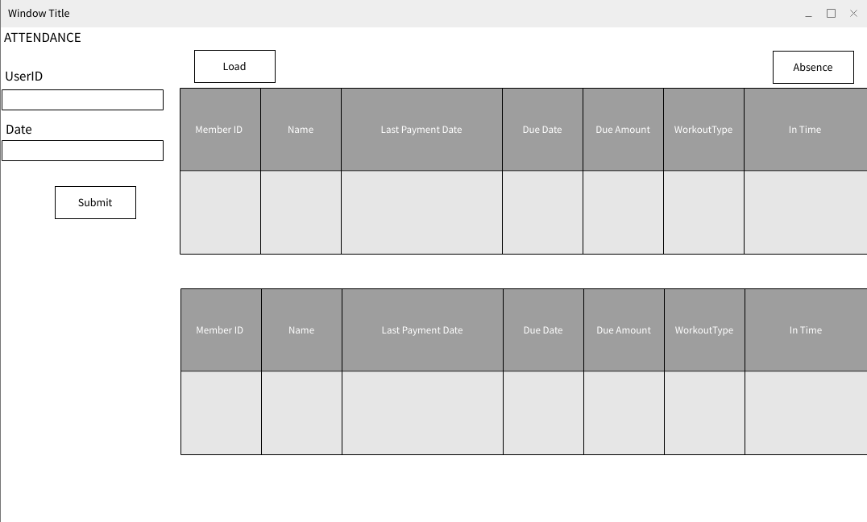

Architecture Diagram

Layer | Logical View | Technology/Framework
Presentation Layer | UI Components  Export (pdf)  Validations  Report  Resources | HTML/ CSS/ JavaScript
Application/ Business Layer | Web-Server Classes  Configuration  Controllers  Service  REST Controllers  Entity/ Model Classes | Java 1.8/ Spring MVC
Data Access Layer | Repository classes  Oracle 11g Database | Spring JDBC

Presentation Layer:
This layer consists of all UI components.
- Export component: The plug-in is used to export the reports in pdf format. It helps to reduce the workload on the web/ application server.
- Validation component: All basic level data validations should be done at UI level.
- Report component: All reports to be generated to the user, will be processed and generated at the browser end.
- Resources: All HTML/CSS/ images, which are required for the page design.

Application Layer:
This layer comprises of all server and business classes.
- Configuration settings (XML or Class based) will define the application and server configuration.
- Spring Controllers defines the server classes, which are required to process the incoming http requests.
- Service classes are required to perform the required business services.
- Controllers to process the HTTP requests.
- Model classes are used the define the functions of the entities present in the system.
Data Layer:
Data layer is implemented through JDBC. It will contain the repository classes, which provides interface to the table.

ER Diagram

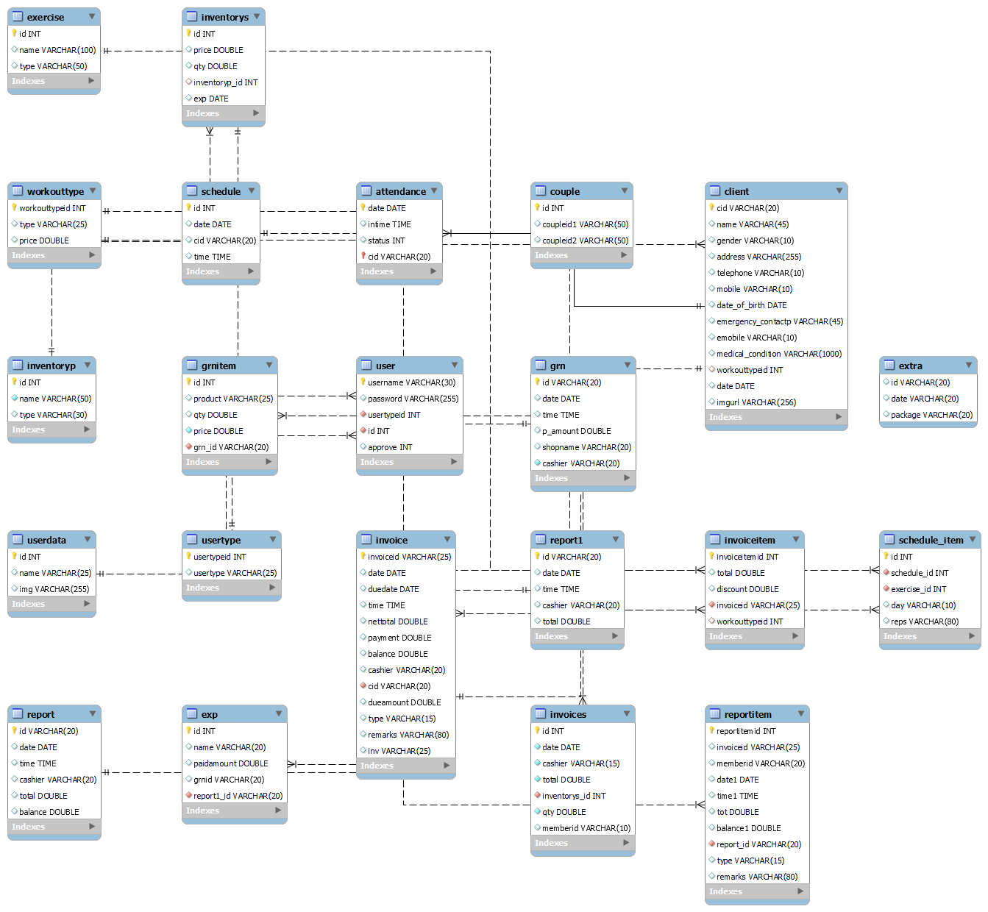

Sequence diagram

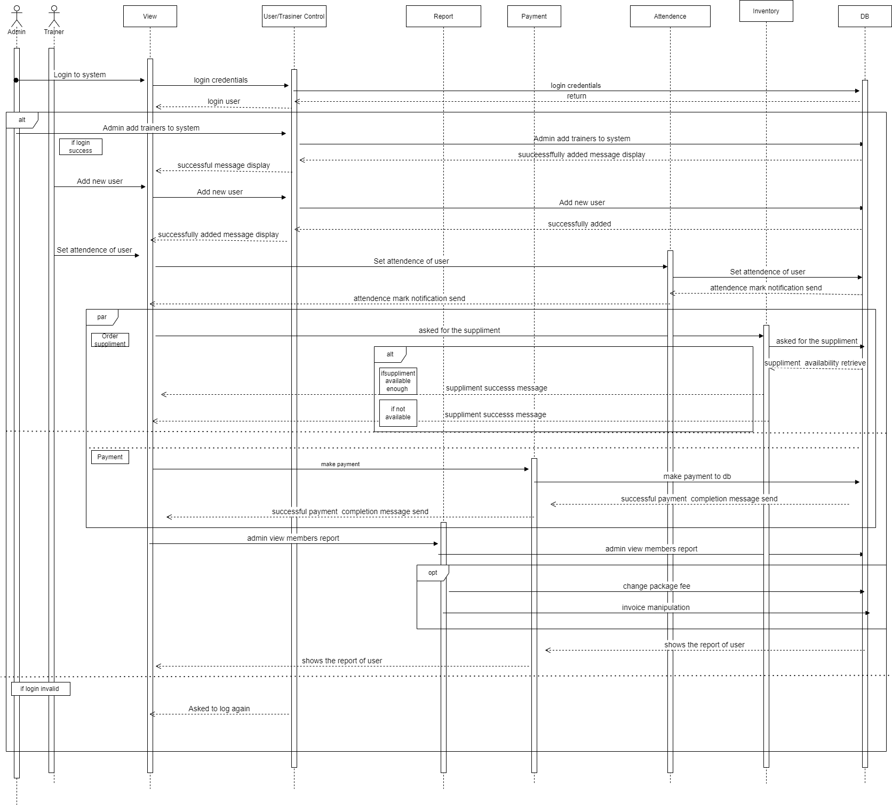

Class diagram

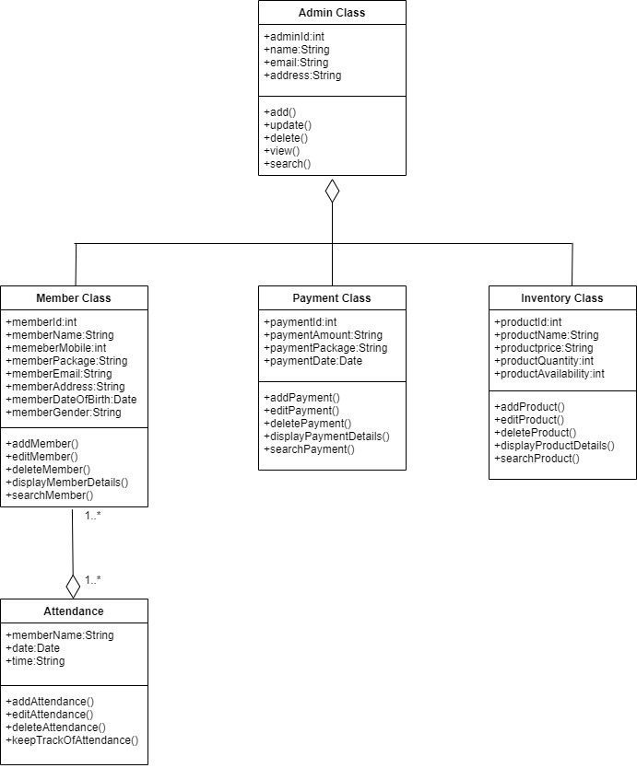

Proposed user Interface design

LOGIN AND REGISTER UI

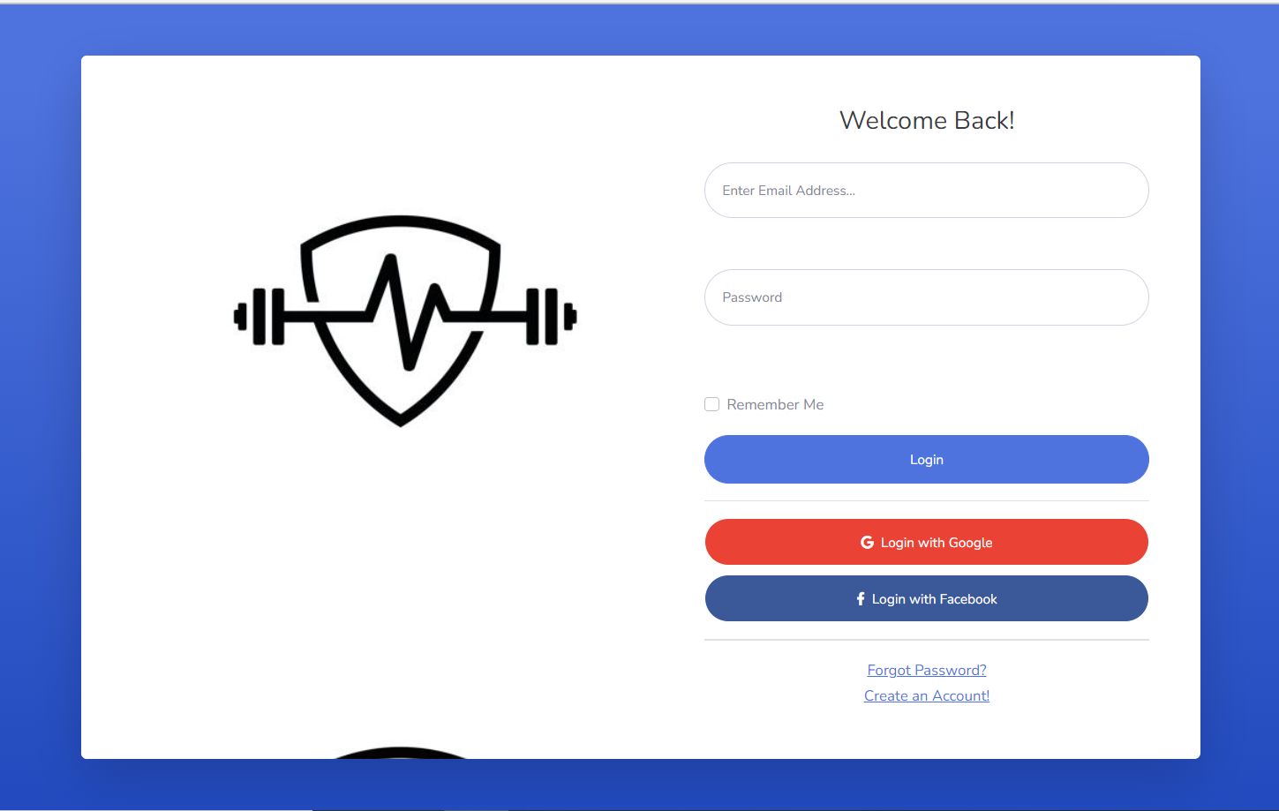

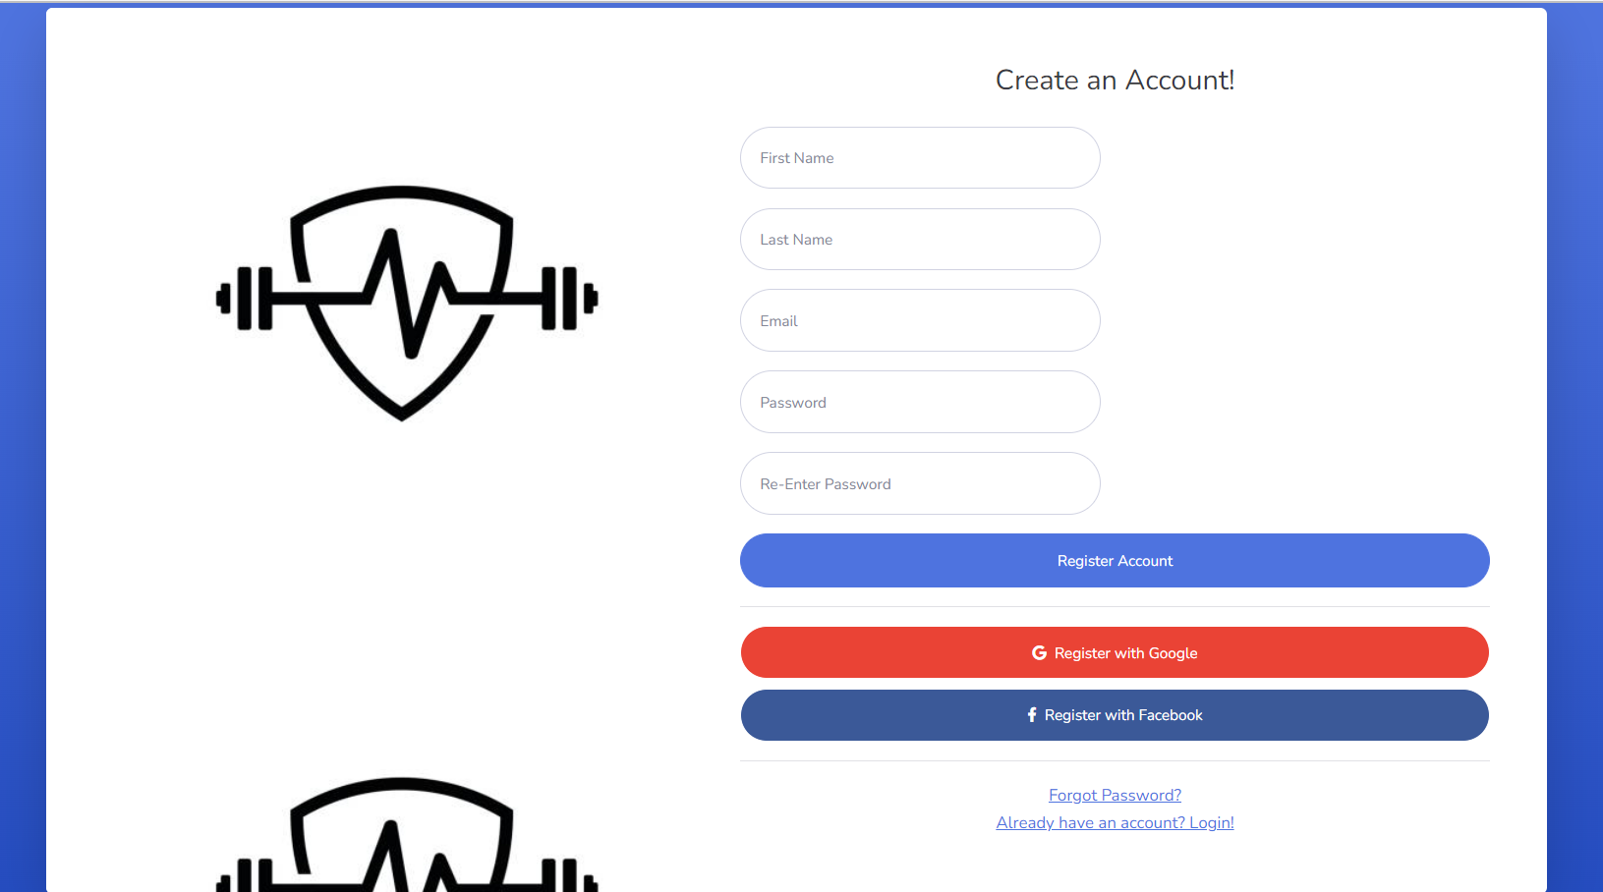

DASH BOARD

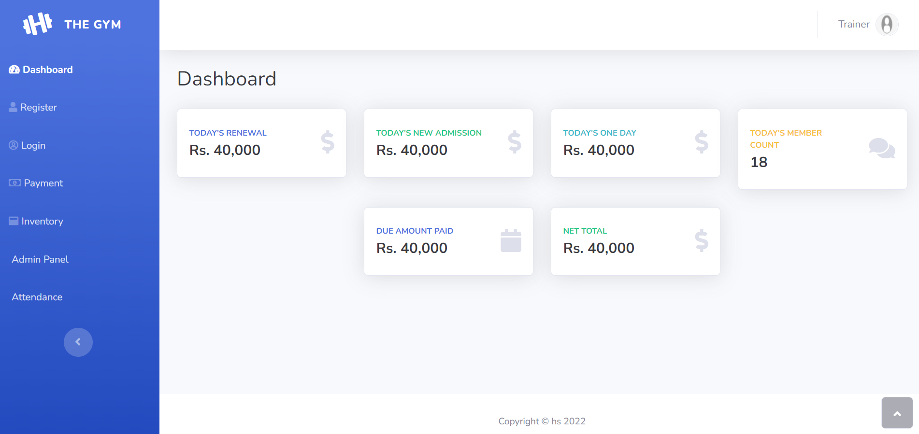

MEMBER REGISTERATION

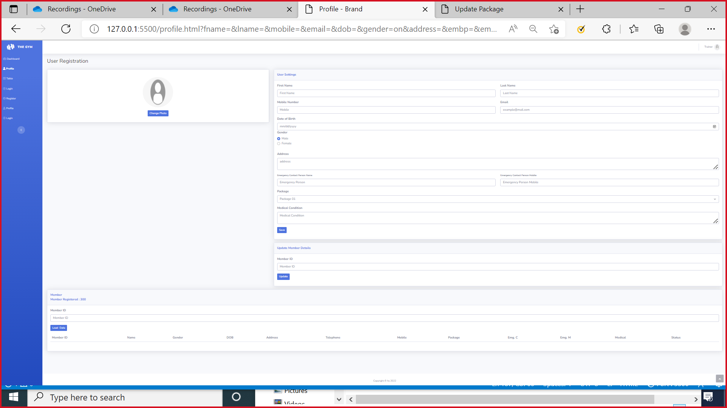

PAYMENT

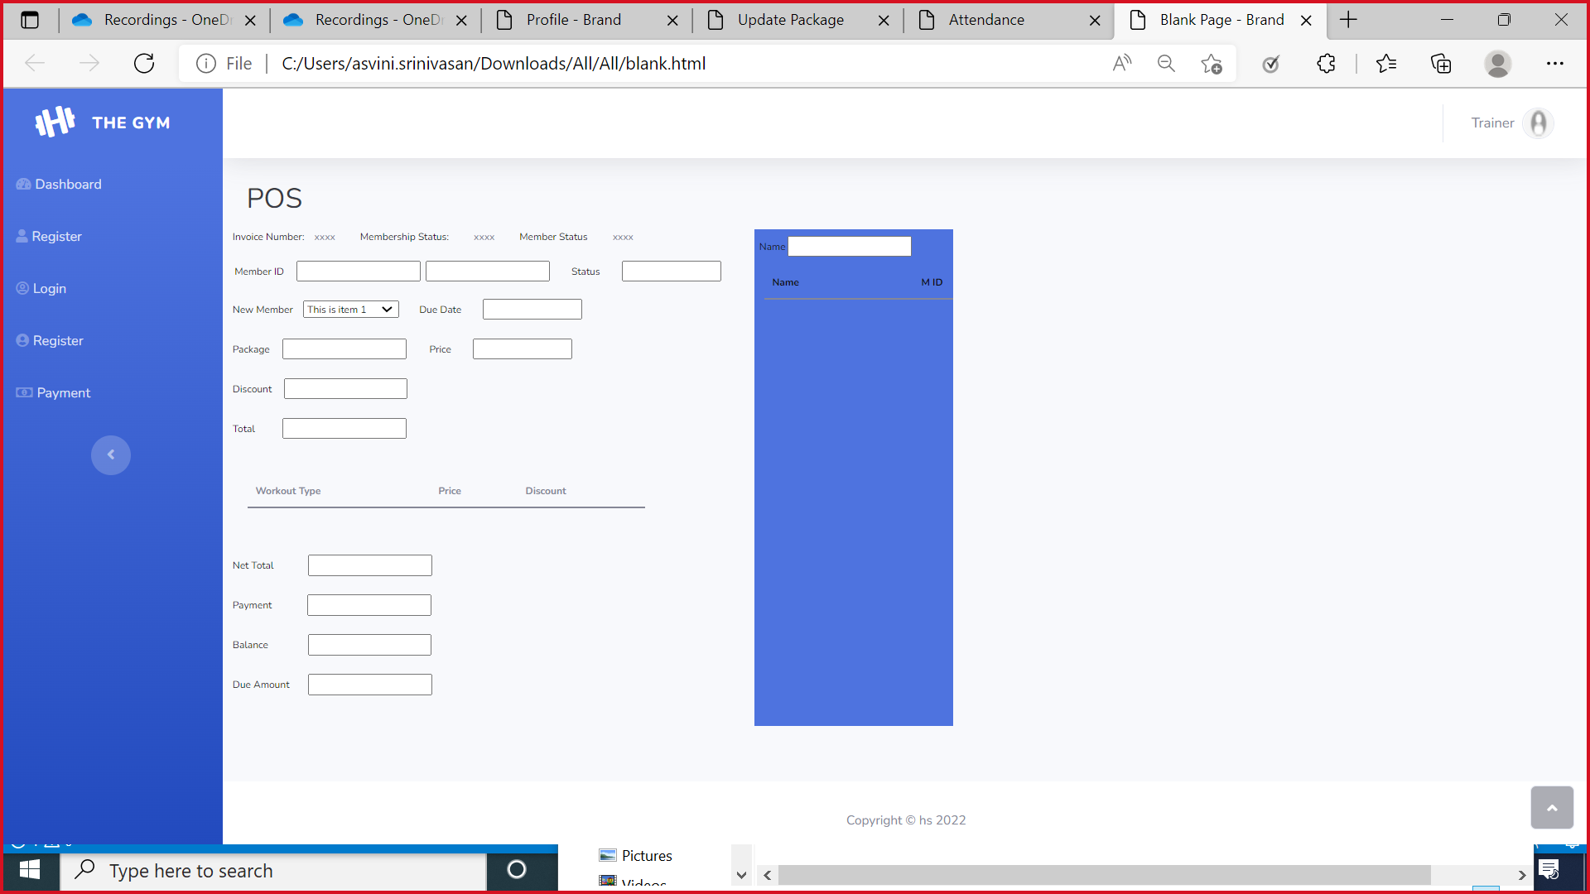

INVENTORY

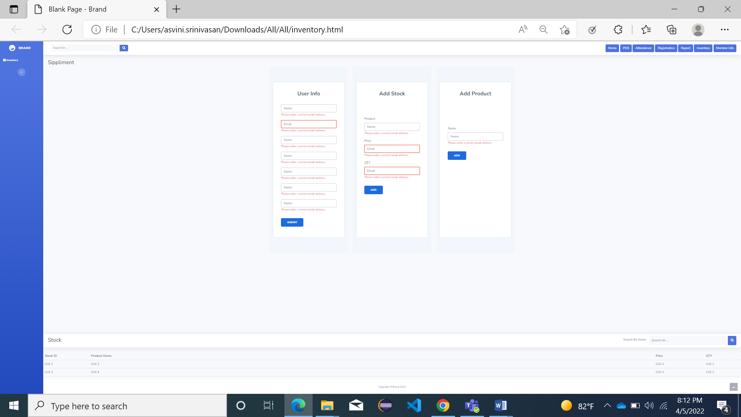

ADMIN

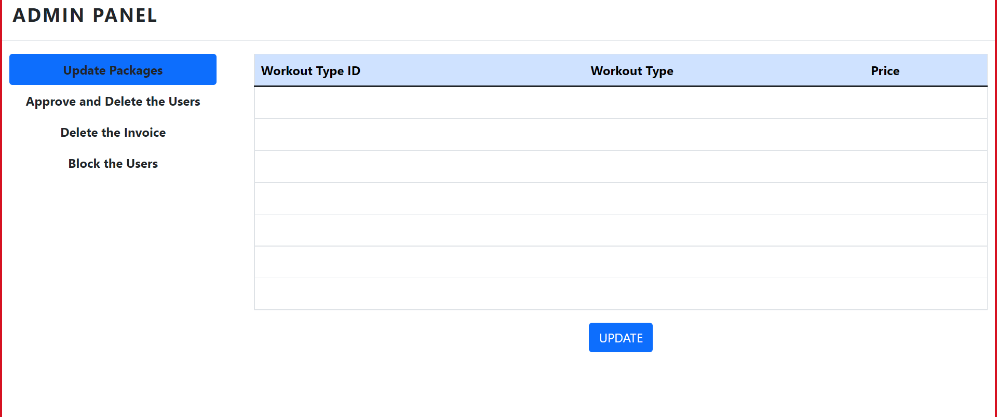

ATTENDANCE

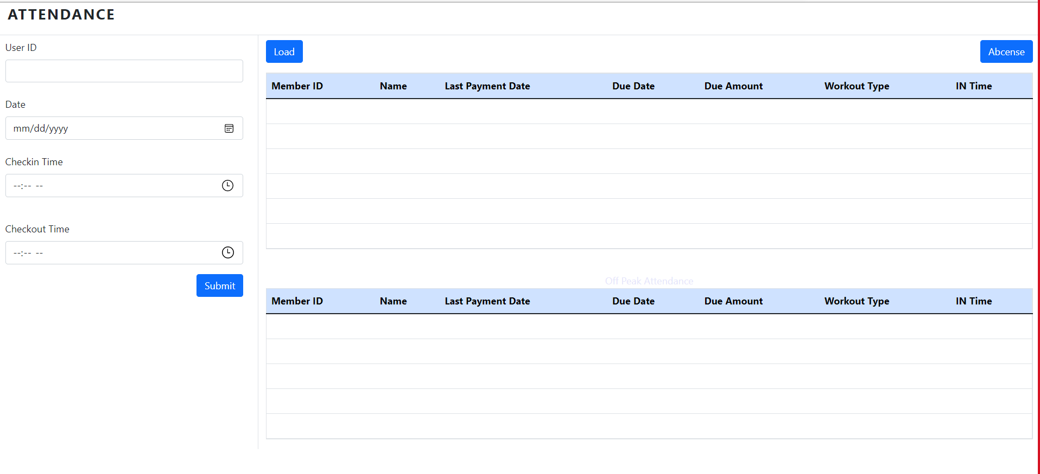

Database design changes

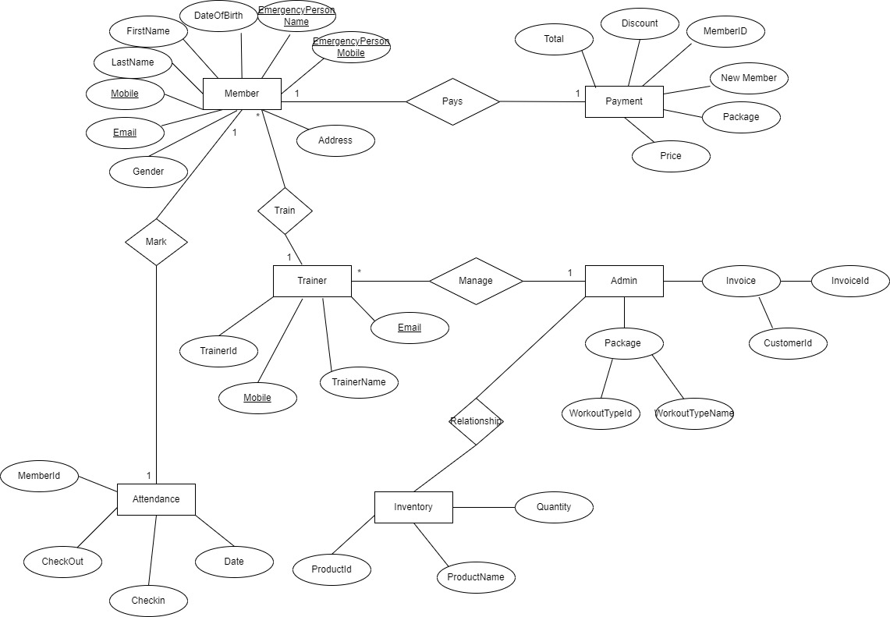

Other Technical changes

Automation tasks
Every software's success depends on its ability to test it. There is no such thing as a perfect system design. There are two stages to the testing process. The first phase occurs during the software engineering phase, which is when the modules are created. The second step begins when the software has been completed. This is system testing, which ensures that the entire set of programs is working properly.

Unit Testing
Each module is considered independently. it focuses on each unit of software as implemented in the source code. it is white box testing.

Integration Testing

Integration testing aims at constructing the program structure while at the same constructing tests to uncover errors associated with interfacing the modules. modules are integrated by using the top down approach.

Validation Testing
Validation testing was performed to ensure that all the functional and performance requirements are met.

System Testing
It is executing programs to check logical changes made in it with intention of finding errors. a system is tested for online response, volume of transaction, recovery from failure etc. System testing is done to ensure that the system satisfies all the user requirements.

Non-functional and functional related changes
Non-functional

Usability: The application is user-friendly and no prior knowledge is required to access it. Application is simple and easy to use.

Reliability: Database updating should follow transaction processing to avoid data inconsistency.

Availability: The project will be deployed on a user shared server so it will be available all the time and will be accessible anywhere of the world using internet.

Security: we have implemented a lot of security mechanism to avoid to hack the system by outer world.

Maintainability: it is very easy to maintain the system.

Portability: The application can run on any system having Windows OS. So you can use it wherever you want.

Browser Compatibility: the project being web based required compatibility with at least the popular web browsers (Microsoft Edge, Google chrome).

Functional

The system runs of apache server so it is needed that server must have apache tomcat server version 9.0 available

We have used HTML for server side scripting so the current version of HTML must be available on the server

Oracle database has been used for storing the data of the website

HTML has been used for creating the layout of the web application

CSS has been used for creating the designing of the webpages

User can Viewing client details, viewing inventory details, Authentication by login and Viewing machine details, User can change personal details any time, can interact with trainers

References
< Provide reference details if any >

